

**BRAND MERCHANDISING**

**Project Report**



**Crea MARKETING SERVICES pVT. LTD.**

**A 1/10, 1st Floor, Near Qutub Plaza, DLF Phase 1, Gurgaon, Haryana India – 122002**

**A Project Report on**

**Brand Merchandising**

**Under the Guidance of**

**Mr. Upkar Sharma & Ms. Ipsa Bansal**

**A thesis submitted for the complete fulfillment of the requirements of Business Communication for the award of the degree of**

**BACHELOR OF COMMERCE (HONS.)**

**Submitted by:**

**ASHISH 14054204089**

**Submitted to:**

**Sh. Amit Kumar**

**Associate professor**



**P.G.D.A.V. College (Evening)**

**University of Delhi**

**Nehru Nagar, Ring Road, New Delhi - 110 065**

**2016-2017**

**Certificate**

This is to certify that Mr. Ashish has completed his Summer Training Project under my direct supervision. He underwent the Summer Training on and from 19th of December 2016 to 19th of July 2017, during which he was assigned the task to “maintain data base and research” of the clients being marketed at PSI Germany of 2016 and 2017 which he has successfully completed and provided him the general knowledge of brand merchandising. The same is presented in the form of the present Project Report.

It is further certified that the project report submitted by Mr. Ashish reflects his original work and on the work assigned to him for the Summer Training.

Signature: Date:

Mr. Upkar Sharma

Director

Crea Marketing Services Pvt. Ltd.

**DECLARATION**

I*,* Ashish, a bonafide student of B.COM (Hons.) at the PGDAV College (Eve.), University of Delhi, hereby declare that I have undergone the Summer Training at Crea Marketing Services Pvt. Ltd., under the supervision of Mr Upkar Sharma and Ms. Ipsa Bansal from 19-December-2016 to 19-February-2017.

I also declare that the present project report is based on the above summer training and is my original work.

Place: New Delhi Ashish

Date: 14054204089

**ACKNOWLEDGEMENT**

Praise is to God, the Lord Almighty and All Knowing, who blessed me with the knowledge, wisdom and strength to complete this project successfully.

I express my sincere thanks and acknowledge our Institution “PGDAV College (Eve)” and team of Crea Worldwide for fostering an excellent academic ambience and infrastructure without which the project would not have reached to its goal. Firstly, I express our gratitude to and Sh. Amit Kumar, Associate Professor and Mr. Upkar Sharma (Director at Crea Worldwide) for their conceptual and procedural assistance to me in the formative stages of our project. They have been the source of inspiration throughout by their positive approach and never ending helpful attitude towards the completion of the project. I express my heartfelt appreciation to them for their precious advice and valuable guidance throughout my project. I also extend my thanks to the staff of the company who helped me in many possible ways.

**INDEX**

|  |  |  |
| --- | --- | --- |
| **S.No** | **CONTENT** |  |
| **Ch.1** | ***Synopsis***   * Abstract * Statement of problem * Scope of study * Research Methodology * Type of research * Sample Data * Collection of data * Objective of study * Limitation of study |  |
| **Ch.2** | ***Introduction to Brand***   * Brand * Brand Name * Brand Strategy * Brand Strategy Decision * Brand as Marketing * Branding Vs Marketing |  |
| **Ch.3** | ***Introduction to Merchandising***   * Merchandising * Merchandiser * Types of merchandising |  |
| **Ch.4** | ***Introduction to Brand Merchandising***   * Overview * Guerrilla marketing * Success rates Examples * Star war * Being Human * Problems facing by Indian Economy * History * Function * Crea Overview |  |

**Chapter 1**

**SYNOPSIS**

**ABSTRACT**

Retail in Indian market and global market has a very good growth, potential but the bottleneck here is to differentiate one retail business from the other through customer’s perceptions. In order to grab the attention of the customer’s buying decision over retail businesses must focus on various forms of merchandising depending upon the type of business been with. As there are various players in the retail business and more or less every player in the retail industry offers the same thing, thus every retail business needs to be distinguishable from its industry competitors. A successful retailing business needs a good image to be created in the minds of the customers. In order to enable brand image of a retail business to be absorbed by the customers mind, can be achieved through product and service offerings. The means of increasing the footfalls and sales of a retail store, they need to concentrate on Merchandising of products and service offerings. Brand Merchandising is new business etiquette which is growing popular now a days. This is on its peak growth which let one manufacturer to another manufacturer to work together in a single course of action as a result it even leads to global market prospects. It is much more than corporate gifting.

For Example: Samsonite (SAMSONITE SOUTH ASIA PVT LTD.) company which deals in high quality luggage and bags can join hands with any of Brand merchandiser who deals in Bags, Luggage, and other related accessories as well which will provide Samsonite Brand with a variety of ideas and products which will not only increase its sales at retail level but brand value as well. In a Layman’s language brand merchandising helps in promoting brand. As same for the Fashion sector Visual Merchandising plays a crucial role and brand merchandising can be the helping hand.

There is no doubt to say that customer satisfaction is greatly influenced by store environment, shopping comfort and merchandise assortment i.e. visual merchandising. But there might be a competitor right aside to your retail business who might have same or better visual merchandising than yours but here branding is the only marketing strategy which allows your business to stand first in the consumer minds. This study will help businesses to improvise on the weak dimension of their particular brand and simultaneously drive the business towards increased sales and customer satisfaction.

**STATEMENT OF THE PROBLEM:**

The title of the present research is ***“Brand merchandising”.***

Brand Merchandising is often misinterpreted as just corporate gifting in India. Corporates treat merchandise in India as "Give Aways” and fail to understand that brand merchandise as a force is subliminal advertising and is essentially an extension of the brand itself.

According to various reports, the industry is growing at a constant speed of 20-22 per cent every year, with a turnover of over Rs 5,000 crore per annum. In West, the concept of brand merchandising has been taken seriously, but India still needs to understand its potential. In order to bring in stability to this highly unorganised sector in India, domain expert CREA is working hard to educate brands on the power of the brand merchandising.

**Scope of the Study:**

During my internship program I tried to gather as much as information as possible to illustrate a clear-cut image about the importance of the brand merchandising. The guiding principle of the company is to develop and maintain strong, secure relation with vendors to create a stir in the market and it will also help to organize the scattered segment.

To read the report we will able to know clear image about the importance of the Brand merchandising in India but still being in the industry for almost a decade, the industry has grown in size but not evolved. The common excuse is that buyers or brands don't realize the value of taking brand merchandise seriously, instead, they just treat it as a poor cousin of events and activations, almost an afterthought.

The study will also help us to understand the role of Brand merchandising in socio and economic development of the country.

**RESEARCH AND METHODOLOGY**

**Type of Research:**

Descriptive Research is used for the study as it helps fact finding through surveys and enquiries. The data is collected through the primary source, which include On-Job training and visiting company’s client. Secondary data has been collected from internet web page, magazines, journals newspapers etc.

**Sampling Design:**

* Stratified random sampling method is used for sampling design of enterprise’s competitors.
* Selective Sampling method is used for company’s specific client’s case study.

**Sampling Size:**

The sampling size in this research is restricted to limited and samples were collected in different areas of scope.

##### **Sample Description:**

##### The sample consists of all B2B having retail business as its functional activity, customers irrespective of regional boundaries.

##### **Actual Collection of Data:**

The sources of data are primary and secondary data.

**Primary Data:**

The data is collected through the primary source, which include On-Job training and visiting company’s client

**Secondary Data:**

Secondary data was collected by:

* Browsing different website
* Referring various articles, reports, journals, magazines on insurance.
* Referring different books and previous project reports in college library.

**Objective of the Study:**

**Broad Objective:**

To find out the merchandising activities in the corporate sector of India.

**Specific Objectives:**

* To know the Brand merchandising activities of Crea worldwide ltd.
* To know the overall internal and external environment of the promotional markets.
* Identify the major opportunity in marketing, advertising and merchandising sector.
* To obtain general awareness about the Brand Merchandising.
* To compare Branding with Marketing
* To gain an insight of Crea Worldwide and its competitors.
* To do a study on business perception about the Brand Development.

**Limitations of the Study:**

The project report has following limitations:-

* Limited time to complete the project.
* Sample size is small due to limited time.
* Analysis of consumers is limited within district.

**Chapter 2**

**Introduction**

**To**

**Brand**

***BRAND***

A brand is the [identity](http://en.wikipedia.org/wiki/Identity_(philosophy)) of a specific [product](http://en.wikipedia.org/wiki/Product_(business)), [service](http://en.wikipedia.org/wiki/Service_(economics)), or [business](http://en.wikipedia.org/wiki/Business). A brand can take many forms, including a [name](http://en.wikipedia.org/wiki/Name), [sign](http://en.wikipedia.org/wiki/Sign), [symbol](http://en.wikipedia.org/wiki/Symbol), [color combination](http://en.wikipedia.org/w/index.php?title=Color_combination&action=edit&redlink=1) or [slogan](http://en.wikipedia.org/wiki/Slogan). The word brand began simply as a way to tell one person's cattle from another by means of a hot iron stamp.

According to **American marketing Association (AMA)**, "A brand is a name, term, sign, symbol or a combination of these that identifies the products or services of one seller or a group of sellers and differentiates them from those of competitors."

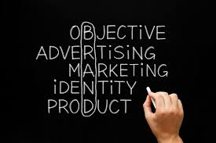

The following table might help in knowing the branding cycle:

|  |  |  |  |  |  |  |  |  |
| --- | --- | --- | --- | --- | --- | --- | --- | --- |
| Branding Decision |  | Brand  Sponsor  Design |  | Brand Name Decision |  | Brand Strategy Decision |  | Brand Repositioning Decision |
| * Brand * No Brand |  | * Manufacturer Brand * Distributor Brand * Licensed Brand |  | * Individual Names * Blanket Family Names * Separate Family Names * Company Individual Names |  | * Line Extension * Brand Extension * Multi-Brand * New Brands * Co-Brands |  | * Repositioning * No Repositioning |

### Brand name

The brand name is quite often used interchangeably within "brand", although it is more correctly used to specifically denote written or spoken linguistic elements of any product. In this context a "brand name" constitutes a type of [trademark](http://en.wikipedia.org/wiki/Trademark), if the brand name exclusively identifies the brand owner as the commercial source of products or services. A brand owner may seek to protect [proprietary rights](http://en.wikipedia.org/wiki/Intellectual_property) in relation to a brand name through trademark registration.

**After selecting the brand name, what next important for each and every company having Brand, is to first select its Brand Strategy after considering various factors such as line of products, target market, etc. for creating a mind set in mind of the customers, competitors and their clients that would headed you to establish brand market with a define Brand name.**

**It’s also important in B2B because it helps you stand out from your competition. Your brand strategy** **brings your competitive positioning to life, and works to position you as a certain “something” in the mind of your prospects and customers. So let’s first know about, What is Brand Strategy and how it can create add value to your Brand effectively.**

So, **WHAT IS BRAND STRATEGY?**

Brand strategy is a long-term plan for the development of a successful brand in order to achieve specific goals. A well-defined and executed brand strategy affects all aspects of a business and is directly connected to consumer needs, emotions, and competitive environments.

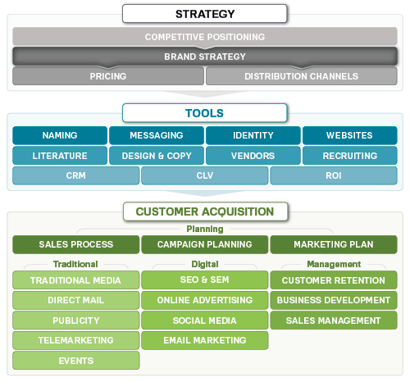

***Below is one the best example of competing brand that have tailored their marketing to accentuate their differentiation to the consumer.***

#### **GILLETTE VS DOLLAR SHAVE CLUB BRANDING**

Gillette has become one of the most recognized brands built on the pillars of professional and masculine razors. [Dollar Shave Club](http://www.dollarshaveclub.com/) entered the market attacking Gillette on price. The name alone shows that they are pushing consumers towards low cost. However, DSC also competes on quality. They further differentiated by creating messaging that is far from Gillette’s professional advertisements – a humorous take that has made the company a major player in the grooming industry.

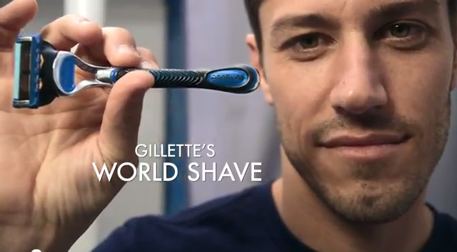

**Gillette**

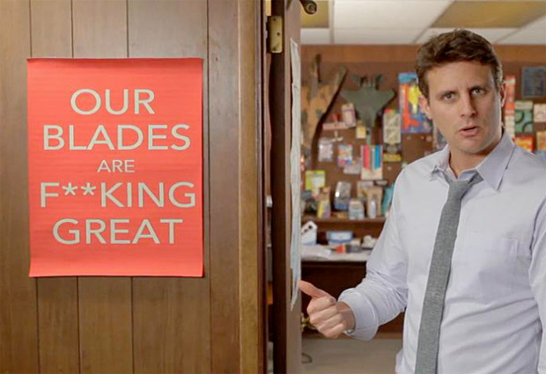

**Dollar Shave Club**

**Brand Strategy Decision**

A company has five choices when it comes to developing brands. It can introduce Line extensions, Brand extensions, multi-brands, or new brands.

|  |  |  |  |
| --- | --- | --- | --- |
|  | | Product category | |
| Brand Name |  | Existing | New |
| Existing | Line extension | Brand extension |
| New | Multi-brands | New brands |

**Line Extension**

Line extensions occur when a company extends existing brand names to new forms, color, sizes, ingredients, or flavors of an existing product category.

A company might introduce line extension as a low cost, low risk way to introduce new products. Or it might want to meet consumer desires for variety to use excess capacity, or simply to command more shelf space from resellers. However line extensions involve some risks. An overextended brand name might lose its specific meaning, or heavily extended brands can cause consumer confusion or frustration.

**Brand extensions**

A brand extension extends a current brand name to new or modified products in a new category. A brand extension gives a new product instant recognition faster acceptance. It also saves the high advertising costs usually required to build a new brand name. At the same time, a brand extension strategy involves some risk. Further, a brand name may not be appropriate to a particular new product, even if it is well made and satisfying.

The existing strong brand name can be used as a vehicle for new or modified products: For example, many [fashion](http://en.wikipedia.org/wiki/Fashion) and designer companies extended brands into fragrances, shoes and [accessories](http://en.wikipedia.org/wiki/Fashion_accessory), home textile, [home decor](http://en.wikipedia.org/wiki/Interior_design), [luggage](http://en.wikipedia.org/wiki/Luggage), (sun-) glasses, furniture, hotels, etc.

Mars extended its brand to ice cream, [Caterpillar](http://en.wikipedia.org/wiki/Caterpillar) to shoes and watches, [Adidas](http://en.wikipedia.org/wiki/Adidas) and [Puma](http://en.wikipedia.org/wiki/Puma_AG) to personal hygiene. [Dunlop](http://en.wikipedia.org/wiki/Dunlop_(brands)) extended its brand from tires to other rubber products such as shoes, golf balls, tennis racquets and adhesives.

*There is a difference between brand extension and line extension:*

A line extension is when a current brand name is used to enter a new market segment in the existing product class, with new varieties or tastes or sizes. When [Coca-Cola](http://en.wikipedia.org/wiki/Coca-Cola) launched "Diet Coke" and "Cherry Coke" they stayed within the originating product category: non-alcoholic carbonated beverages. [Procter & Gamble](http://en.wikipedia.org/wiki/Procter_%26_Gamble) (P&G) did likewise extending its strong lines (such as Fairy Soap) into neighboring products (Fairy Liquid and Fairy Automatic) within the same category, dish washing detergents.

**Multi-Brands**

Companies often introduce additional brands in the same category. Multi-branding offers a way to establish different features and appeal to different buying motives. It also allows a company to lock up more reseller shelf space.

A **major drawback** of multi-branding is that each brand might obtain only a small market share, and none may be very profitable.

As in a market that is fragmented amongst a number of brands a supplier can choose deliberately to launch totally new brands in apparent competition with its own existing strong brand (and often with identical product characteristics)

Once again, [Procter & Gamble](http://en.wikipedia.org/wiki/Procter_%26_Gamble) is a leading exponent of this philosophy, running as many as ten detergent brands in the US market. This also increases the total number of "facings" it receives on supermarket shelves. [Sara Lee](http://en.wikipedia.org/wiki/Sara_Lee_(corporation)), on the other hand, uses it to keep the very different parts of the business separate - from Sara Lee cakes through Kiwi polishes to L'Eggs pantyhose.

New brands

A company might believe that the power of its existing brand name is waning and a new brand name is needed. Or it may create a new brand name when it enters a new product category for which none of the company’s current brand names are appropriate. For example, Toyota created the separate Scion brand.

As with multi-branding, offering too many new brands can result in a company spreading its resources too thin. And in some industries, such as consumer packaged goods, consumers and retailers have become concerned.

**Co brands**

Co-branding is an arrangement that associates a single [product](http://en.wikipedia.org/wiki/Product_(business)) or [service](http://en.wikipedia.org/wiki/Service_(economics)) with more than one [brand name](http://en.wikipedia.org/wiki/Brand_name), or otherwise associates a product with someone other than the principal producer. The typical co-branding agreement involves two or more companies acting in cooperation to associate any of various logos, color schemes, or brand identifiers to a specific product that is contractually designated for this purpose. The object for this is to combine the strength of two brands, in order to increase the [premium](http://en.wikipedia.org/wiki/Premium) consumers are willing to pay, make the product or service more resistant to copying by [private label](http://en.wikipedia.org/wiki/Private_label) manufacturers, or to combine the different perceived properties associated with these brands with a single product.

**Brand Repositioning Decision**

Marketers need to position their brands clearly in target customers mind. They can position brands at any of three levels. At the lowest level they can position the brand on product attributes.

A brand can be better positioned by associating its name with a desirable benefit. The strongest brands go beyond attribute or benefit positioning.

**Conclusion**

A brand is the [identity](http://en.wikipedia.org/wiki/Identity_(philosophy)) of a specific [product](http://en.wikipedia.org/wiki/Product_(business)), [service](http://en.wikipedia.org/wiki/Service_(economics)), or [business](http://en.wikipedia.org/wiki/Business). A brand can take many forms, including a [name](http://en.wikipedia.org/wiki/Name), [sign](http://en.wikipedia.org/wiki/Sign), [symbol](http://en.wikipedia.org/wiki/Symbol), [color combination](http://en.wikipedia.org/w/index.php?title=Color_combination&action=edit&redlink=1) or [slogan](http://en.wikipedia.org/wiki/Slogan).

**Before moving forward there are some terms having lot of confusion around branding, there are multiple definitions, so what is branding**?

Decades ago branding was defined as a name, slogan, sign, symbol or design, or a combination of these elements that identify products or services of a company.

Today brand is a bit more complex, but even more important in today’s world of marketing.

It’s the perception that a consumer has when they hear or think of your company name, service or product.   That being said the word “brand” or “branding” is a moving target and evolves with the behavior of consumers, I think of it as the mental picture of who you as a company represents to consumers, it’s influenced by the elements, words, and creativity that surround it.

**Marketing plays a very crucial role in branding:**

A strong [brand](https://www.thebalance.com/define-your-brand-identity-2294834) is invaluable as the battle for customers intensifies day by day. It's important to spend time investing in researching, defining, and building your brand. After all, your brand is the source of a promise to your consumer. **Brand is strategic and marketing is tactical and what you use to get your brand in front of consumers.** That's why it carries a great deal of importance within a business or organization as well. As such **Brand marketing** plays a major role in it.

**BRAND MARKETING**

**Brand marketing** is the process of marketing products and services in a way that supports the brand and helps consumers understand the mission of the company.

For instance, celebrities create a brand that represents who they are and what type of work they do, in order to draw people to them. **Lady Gaga** and **Madonna** are two iconic celebrities who have built well-known brands for being on the cutting edge of music and entertainment. They have both established themselves as innovative artists who will use shocking costumes and scenery to get attention, create demand for their music, and create a fan following.

# **Where Marketing Ends, Branding Begins**

**Before this, I think branding with a scenario what we all probably think branding involves the following:**

* **Logos, color schemes, and website design**
* **Logos, color schemes, and website design**
* **SERPs visibility, ad campaigns, and other promotional efforts**

**But we were looking at branding in the wrong way. The items I mentioned are all marketing tools and strategies, and they only scratch the surface of branding.**

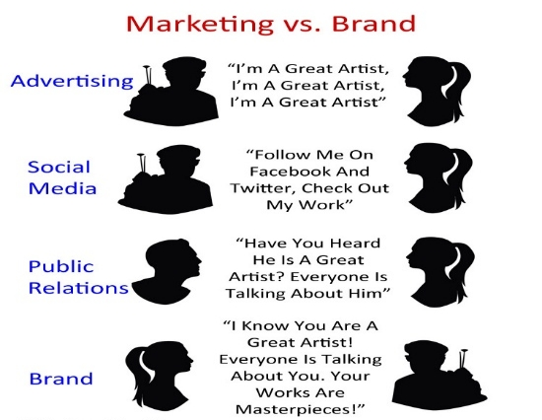

**Misconception #1**

Marketing, advertising, and other promotional activities only communicate your brand personality and message. Your brand is comprised of your personality, your voice, and your message; branding is the process of establishing these traits.

**Misconception #2**

This is a very common misconception, especially among first-time business owners. The truth is while you set the tone and get the ball rolling so to speak, and you set the guidelines that your organization will follow and live by as they work with your brand, this does not automatically make you the ultimate brand authority.

Your customers are the ones who ultimately define your brand. Their perception of your brand is what sticks with the people they influence. This is why it’s very important to select your brand values carefully; otherwise, your brand may be taken the wrong way – or worse, it may fail when you don’t see repeat customers.

## **Conclusion**

## One final thing to remember – and a very important point – is that branding isn’t a one-time thing that you do at the beginning of establishing your business. It is an ongoing effort that permeates your processes, your culture, and your development as a business, and it requires your dedication and loyalty in order to reflect in your work. At the end of the day, the true measure of your branding success is in earning loyal customers who become your brand ambassadors as well.

**Chapter 3**

**Introduction**

**To**

**Merchandising**

**MERCHANDISING**

**Definition**

The activity of promoting the sale of goods at retail. Merchandising activities may include display techniques, free samples, on-the-spot demonstration, pricing, shelf talkers, special offers, and other point-of-sale methods.

According to **American Marketing Association**, merchandising encompasses "planning involved in marketing the right merchandise or service at the right place, at the right time, in the right quantities, and at the right price.

As the question arises that at what trade level merchandising can be assumed i.e. at which stage merchandising company mechanisms.

A **merchandising company** is a company that buys goods and then resells them, generally for a higher price than they were purchased.

There are **two** types of merchandising companies - retail and wholesale. A **retail** company is a company that sells products directly to customers, where a **wholesale** company is a company that buys items in bulk from manufacturers and resells them to retailers or other wholesalers.

**Merchandiser:**

Merchandisers are “image consultants for the retail world”. [Merchandisers](http://www.snagajob.com/job-search/q-merchandiser) also deliver educational materials to the store for training new employees or teaching sales tactics to existing workers. They also conduct inventory reports:

* Counting the merchandise at a particular location
* Replace old or defective stock.

**Under each merchandising every merchandiser has its own different roles.**

**Types of Merchandising:**

* **Retail Merchandising:**
  + **Visual Merchandising**
  + **Food Merchandising**
* **Promotional Merchandising**
* **Fashion Merchandising:**
  + **Export Merchandising:** 
    - **In an Export Production House**
    - **In Buying House**
  + **Retail Merchandising:** 
    - **For domestic Market**

**NOTE: Still there are lots of merchandising which depends upon the nature of trade and trade’s planning. Here we only going to study above only and most importantly these all merchandising are somewhere related to each other in a trade. But our main focus will be on Brand merchandising.**

1. **Retail merchandising:**

Retail Merchandising refers to the countless activities which contribute to the sale of products to the consumers for their end use. Every retail store has its own line of merchandise to offer to the customers. The display of the merchandise plays an important role in attracting the customers into the store and prompting them to purchase as well.

Merchandising helps in the attractive display of the products at the store in order to increase their sale and generate revenues for the retail store.

**Visual Merchandising:**

**Visual merchandising** is the practice in the retail industry of developing floor plans and three-dimensional displays in order to maximize sales. Both goods and services can be displayed to highlight their features and benefits.

**Food Merchandising:**

A **food** merchandiser is an expert in packaging and displaying **food** to make it appealing to consumers. If you took a job in the **food merchandising** field, you could work for a large **food** or beverage producer, visiting grocery stores to help promote and place your products.

1. **Fashion Merchandising**

Fashion merchandising is the promotion of apparel sales and involves all of the tasks necessary to deliver the clothing requests and meet the needs of potential customers and designers. Fashion merchandising comprises developing campaigns, displays and advertisements, directing manufacturing and marketing as well as creating sales strategies for the fashion industry or the retail environment.

Fashion merchandisers work with designers to ensure that designs will be affordable and desired by the [target market](https://en.wikipedia.org/wiki/Target_market). Fashion merchandisers' decisions can considerably impact the success of the manufacturer, designer, or retailer for which they work.

**Export Merchandising:**

**Export merchandising** is a method of offering retail goods for sale in a foreign consumer market. Many large companies across the country maintain entire divisions devoted to finding ways to better enter foreign retail markets through **export merchandising** to increase profit and sustain growth.

But **Apparel export merchandising** may be defined as ‘all the planning & activities involved right from the buyer  communication & order receiving till the execution or shipment of the order by fulfilling the following factors (Six Rights):

1. **Right Merchandise**
2. **Right Place**
3. **Right Time**
4. **Right Quantity**
5. **Right Price**
6. **Right Promotion**
7. **Promotional merchandising/ Brand merchandising:**

Promotional merchandising involves employing promotional products to help companies and other organizations advertise their products and services.

According to the Advertising Specialty Institute, more than 750,000 different products are available for use in promotional advertising campaigns and promotions. The collection of products available for promotional merchandising range from clothing items to functional office gifts.

**It is the part of Marketing and Advertising as well.**

**Promotional items:**

**Common items include**[**t-shirts**](https://en.wikipedia.org/wiki/T-shirt)**, caps, key chains,**[**posters**](https://en.wikipedia.org/wiki/Posters)**,** [**bumper, stickers**](https://en.wikipedia.org/wiki/Bumper_sticker)**,** [**pens**](https://en.wikipedia.org/wiki/Pen)**,**[**mugs**](https://en.wikipedia.org/wiki/Mug)**, bags,** [**toys**](https://en.wikipedia.org/wiki/Toy)**or**[**mouse pads**](https://en.wikipedia.org/wiki/Mousepad)**.**

Most promotional items are relatively small and inexpensive, but in addition it also have some higher range of items such as handbags, scarves, trolleys, wine bottles, etc. depending upon the industry trading with.

**Chapter 4**

**Introduction**

**To**

**Brand Merchandising**

**Brand Merchandising**

**Overview**

Is the ability to take a company logo or “**brand**” and effectively place it in products that are purchased or used by consumers. **Brand merchandising** is a form of general awareness and more successful companies utilize it.

Brand merchandise is used globally to promote brands, products, and corporate identity. They are also used as giveaways at events, such as exhibitions and product launches. Promotional products can be used for non-profit organizations to promote their cause.

India is one of the e merging country in this sector and with some steady speed and high profits as well.

**Brand Merchandising is completely based on Guerrilla marketing.**

### Guerrilla marketing is an advertisement strategy concept designed for businesses to promote their products or services in an unconventional way with little budget to spend.

**Brand awareness is the most common use for promotional items. That’s what the reason the term Brand Merchandising arises.**

Promotional merchandise is rarely bought directly by corporate companies from the actual manufacturers of the promotional products. A manufacturer's expertise lies in the physical production of the products, but getting a product in front of potential customers is a completely different skill set and a complex process.

# Brand merchandising industry internationally is a multi-billion dollar Industry that is a force to reckon with. Business usually takes it so easily but it is an untapped biz route to success.

# **Brand Merchandising: An untapped biz route to success**

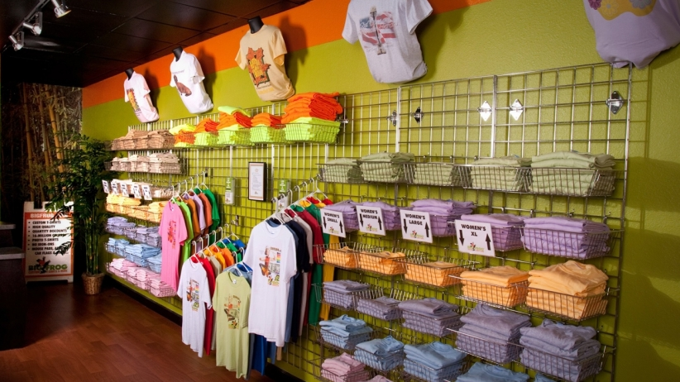

**Example:**

In 2012, when **George Lucas sold the Star Wars franchise to Disney for 4.05 billion USD**, it created a worldwide buzz and there were many who called the acquisition grossly overpriced and ridiculous. The movie series, which had over 7.5 billion USD in combined box office receipts for all of its 6 releases, was seen as a diminished property at the box office. What made Disney pay an astronomical sum for a franchise that was petering out? The answer lies in not at what the movie makes at the box office but what the popular characters of the movie lend themselves to!

The toys, the games, the masks and those light sabres that a generation of kids grew up playing with have so far generated a whopping 20 billion USD! This is the power of Brand Merchandise. 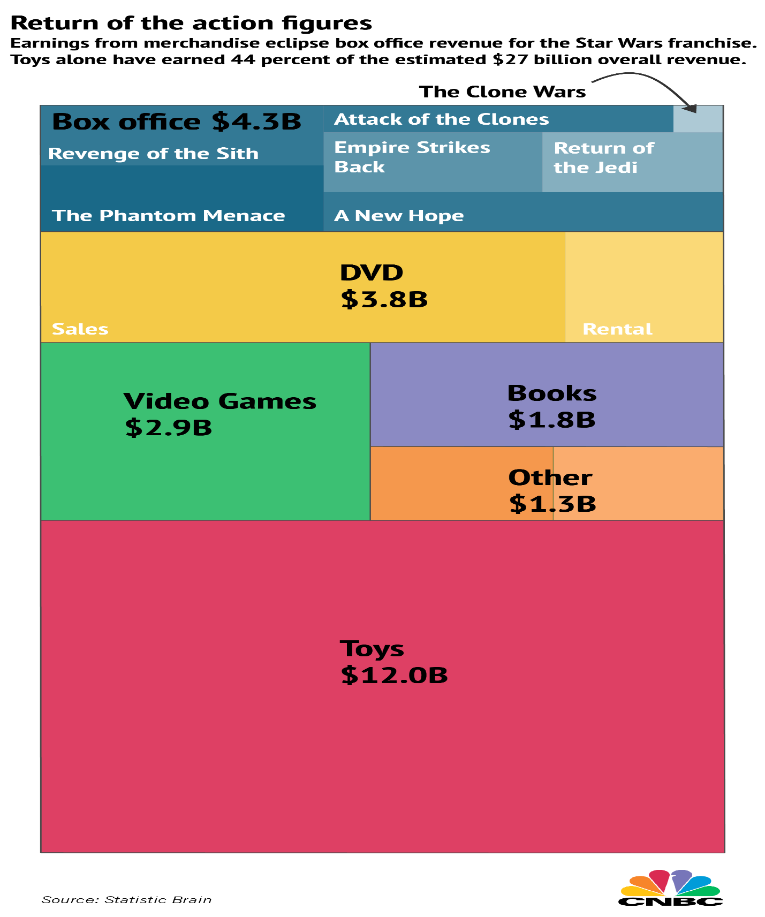

Brands globally take merchandise seriously and anything that has their name on it is an extension of their brand. This seriousness has created many success stories.

In India, **Being Human** is an example worth Rs 100 crore of brand merchandise for which people yearn. They put in their money to buy its T-shirts, caps, bags and other accessories.

**Problems being faced by this sector in India**

**Indian companies and Indian offices of global corporates treat merchandising as an expense and not as a possibility**. The result is shoddy and repetitive merchandise with poorly-placed logos screaming cavalier attitude or sheer nonchalance towards a great opportunity of subliminal branding and possibly an alternate revenue stream.

The brand merchandise industry in US and Europe is an organized industry with dedicated lobbyists and an industry body that serves as the guiding light for the businesses and provides for knowledge sharing and collaboration. With turnover that surpasses 20 billion USD in America and over 7 billion USD in Europe. This is a serious business.

**However, in India in spite of a total turnover that exceeds 2 billion USD, there is no industry body, no credible source of information, and data and it has no government policy as it is not regarded as an industry.**

The problem is not just the fact that there is no cohesive policy or leading body for this industry to be taken seriously, the problem is inability of people involved in brand merchandising to rise over their petty insecurities and start collaborating. In an environment where price is the deciding factor for everything, quality, innovation and thought take a backseat.

The industry is mired in corruption and cowers to purchase departments of organizations, partly because brand teams of Indian companies have been forever treating brand merchandise as an after-thought. It has been an industry which is relationship centric, with no entry barriers. **Anyone who knows anyone in a company can become a supplier of corporate gifts (as it’s generally called in India).** Despite thousands of buyers and equal number of sellers, the industry is disorganized, fragmented and there are hardly any specialist companies in the business who are grossing more than Rs 100 crore in annual turnover.

**It’s these inherent structural and mindset issues that prevent VCs from touching startups in this industry. Couple of investments have already gone badly and as per the VCs, this industry is simply not scalable.**

It’s an uphill task but there are international and Indian players in this arena, who have started slowly and painstakingly churning its wheels. However for any sort of breakthrough, all stakeholders in this industry**, the brands and the vendors need to realize that brand merchandising does not start with the product or its cost, it starts with the BRAND.**

**History**

In 1904, 12 manufacturers of promotional items got together to found the first [trade association](https://en.wikipedia.org/wiki/Trade_association) for the industry. That organization is now known as the [Promotional Products Association International](https://en.wikipedia.org/w/index.php?title=Promotional_Products_Association_International&action=edit&redlink=1) or PPAI, which currently has more than 10,000 global members.

## At this time an ever increasing number of corporate companies recognized the benefits gained from promoting their [corporate identity](https://en.wikipedia.org/wiki/Corporate_identity), brand or product, with the use of gifts featuring their own logo.

**By 2007, catalogues were being mailed to targeted customer lists, rather than the blanket postal mailings that had taken place before. The catalogue had now become seen more as a ‘**[**business card**](https://en.wikipedia.org/wiki/Business_card)**’ demonstrating the concept of what a company did, rather than a critical sales tool.**

## **Function**

Each promotional product used in promotional merchandising is imprinted with information related to the company or event. Depending on the goal of the promotion, imprints typically include the company name, logo or event slogan. With promotional merchandising, companies and organizations can create a targeted advertising campaign while providing recipients with a useful and functional item.

***Subsequently realizing the future growth aspects in this industry for an economy by the Upkar Sharma in spite of serious complications being faced by this economy, He started his company with the name of:***

**Crea Worldwide**

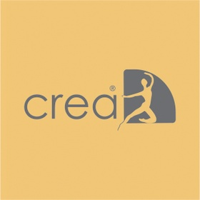

Established in 2008, Crea has graduated from being a 2 person Business Centre, time share office to a multinational sourcing agency and a manufacturing enterprise serving over 400 clients in 18 countries, 4 continents and 7 different time zones. All they ever want to do is to create the coolest, the trendiest and “wow” inducing merchandise for your brand and we work very hard at it. Crea aspires to be the best name in brand merchandising arena in the world. It has also spread its business in 3 countries UAE, CHINA and HONGKONG.

## **Growth in company**

The venture claims to have grown at a consistent rate of 65% year-on-year for the last five years. It clocked a combined turnover in excess of Rs 15 crore for fiscal year 2015-16 and is expecting and working to cross Rs 25 crore this financial year.

Crea is working with some of the best-known brands in the world - Google, Pernod Ricard, Loreal, Ritz Carlton hotels, Pizza Hut, Vero Moda, Jack Jones and Kohinoor Foods, among others.

Bestowed with an opportunity to clear the air on this discipline, allow me to inform you that the arena of brand merchandising consists of a multitude of like:-

•**Corporate Gifts -** The usual suspect and the most commonly used merchandise stream consists any merchandise element like t-shirt, pen, clock, mug or any other utility item, printed with logo of the organisation footing the bill, given as a token of appreciation, reward, gratification, festival gift, contest reward to consumer, channel partner, trade partner or contest winner.

•**Awards & Rewards -** Trophies, mementos, plaques or shields that you see adorning the office cabinets, display shelves of employees, dealer & distributors, actors or even sports people, are a part of brand merchandising too. If IPL is the brand, the trophies and medals it rewards come under brand merchandising

•**Uniforms & Promotional Wear -** Ever run a marathon, got a promotional tee or seen a car mechanic at your nearest company authorised service centre wearing the uniform? All of it is a part of brand merchandising too. The apparel used by the brands and companies remain the most vocal brand ambassador, with big logos screaming out from those t-shirts, seeking and getting your attention!! While at it, let me dispel another notion, corporate apparel need not always be emblazoned with big logos or be cheap throw away variety. It can be used in many qualities and for many purposes, a throwaway t-shirt for a one day event is as much a part of brand merchandise as a high end, top of the line golf shirt for a tournament with sponsor logo is.

•**On pack & In pack Promotions** **-** Remember the time when you spent all your pocket money on buying those chips packets, so you could get that beyblade, tazo or that fancy washable tattoo? If you are too old to remember that, you must remember your kid forcing you to buy that chocolate flavored malt drink so he/she could get a snazzy digital watch in the jar. Well, that is brand merchandising at play. Yes, elements of brand merchandise are used to boost sales by luring the target audience with such gifts. Next time when you buy not one but 2 bottles whiskey from the duty free that you don't really fancy because it comes with an awesome trolley bag that you really want, its brand merchandising at play.

•**Value added Packaging / Product Packaging -** Never judge a book by its cover, we all have been told that, but who listens and for a good reason. When walking the aisles of the supermarket or a liquor store, how do you determine what new product to try? What appeals to your impulse and why? Well, brands know that and that is why they invest in “wow” inducing packaging to help you loosen those purse strings. Packaging, the look, the feel, the quality of it or the versatility of it nudges the consumers into making that “BUY” decision marketers vie for. Almost every brand invests a significant part of its product cost in packaging, for in the consumerist world we live in, doesn't matter how good you are, in the end it boils down to how good you look.

**Crea works on the following segments:**

**PRODUCTS:**

* **DESKTOP ACCESSORIES**

Stationary, corporate gifts, clocks and watches, writing instruments

* **LUGGAGE**

Travel Gear, Backpacks, Office and Messenger Bags, Hard case and Soft case Trolleys, Hiking and Camping Bags

## **TECH STUFF**

Gadgets and Gizmos, USB, Power Banks, Solar Power Gifts

**SERVICES:**

## **VALUE ADDED PACKAGING**

Packaging Design, Tin Packs, Eco Friendly Packaging.

## **UNIFORM SOLUTIONS**

School uniforms, Sports uniforms, Industrial uniforms, Hotel and Airline uniforms.

## **MOVIE INDUSTRY SOLUTIONS**

Movie Promotional Merchandise, Fan Merchandise and Collectibles, Freebies.

## **PROMOTIONAL MERCHANDISE SOLUTIONS**

On Pack Merchandise, In Pack Merchandise, Gift with Purchase.

## **TURN KEY BRAND MERCHANDISE SOLUTIONS**

Concept & design, Prototyping, Mold Development, Mass Production, Logistics and Last Mile Deliveries.

## **Market segment & challenges**

According to experts, though there are no serious studies available in the segment, there over 5000 players active in this business. However, the sector has some serious structural deficiencies.

“It’s one of those industries that steadfastly refuses to evolve or integrate because there is no consolidation or any effort in that direction.

**Competition**

In this market, which is completely unorganized, there are many small players and vendors doing business and raking in money.

Besides, some known names, such as **eYantra**, **Dolphin Displays**, and **BrandStick**, are offering services in brand merchandising.

Companies like **eYantra** in India have tried to scale up but haven’t been able to make a dent in the universe, in spite of being adequately funded. If you look around, virtually all of **Crea’s** competitive landscape is populated by vendors with catalog-driven websites.

The venture also faces competition from brands and their institutional sales divisions, gifting websites, and other office products providers.

**Crea’s Approach**

Crea, understand the importance of building programs that compliment your organizational culture, can be drilled down from your corporate vision and accentuate your brand and its flag bearers’ (Your People) brag quotient. To elevate your aspirations and be able to write success stories for your brand, Crea adopts a 4 stage approach to develop customized solutions.

***Strategy Formulation***

* Organizational Objectives/ Vision
* Program Philosophy & Budget Computation
* Inter & Intra Industry Benchmarking

***Organizational Diagnostics***

* Employee/ Customer Demographic Study
* Regional Consumer Behavior Study
* Evaluation Metrics

***Program Design***

* Framework Design & Program Component Definition
* Technology Framework & Integration Plan

***Program Implementation & Evaluation***

* Pre-launch communication campaign
* Process proliferation & change management
* Technology Testing & Go-Live
* 3 Pronged Evaluation technique based on Kirkpatrick’s Mode

***Case study:***

##### Delivering On-demand Corporate Gifting & Promotional Product Solutions:

NUMERO UNO | Jeanswear

Industry – **Fashion Industry**   
Program - **Corporate Gifting and Promotional Gifting**

**Scenario**  
One of India's largest jeans manufacturers was looking for a one stop solution which could ensure clear and crisp communication. At the same, ensure better recall value, visibility and ensure loyalty. One of India's Jeans wear manufacturers with operations and outlets across the country wanted to communicate the superior quality of its products and gifting solutions to their customers for not only increasing the Brand width but also offering them some extraordinary concept of products.

**Solution**  
Initially, Crea started with a detailed market study, where Crea identified the opinion leaders at different levels in the lifestyle business and designed products that appeal to them.

At the innovating, modifying and upgrading phase it is the Youth which was taken in consider. During the quality phase it was parents and business man been considered. While at a trade level it was the actual customer been considered with different mind sets.

Crea’s challenge was to devise unique merchandising gifting solutions, which would be functional while at the same time represent the quality value proposition of the Client. Crea here performed exceptionally well with the help of their designers and Advertising & marketing head as they come with an idea of offering NUMERO UNO Jeanswear brand with the Bags being made up of their unutilized stock of jeans. It was with the praise of designers they made some extraordinary bags which can’t be imagine while being in the market where people loves leather bags only and moreover their customers now get some new fashioned BAGS made up of jeans only which they before move to get them through any other Brands. Crea offer them Messenger bags, Backpacks, Duffels, String bags, etc.

**Outcome:**

Crea, has truly been a one-stop-shop for all the gifting and communication requirements. The branded merchandise one of India's largest Jeanswear manufacturers was much sought after and created a very positive feel for the brand. Crea strategy played a crucial role while attaining the desired objective, ensuring clients motive to be fulfilled.

**These are some of the concepts which I got to learn while interning at Crea Worldwide from my Brand head and the founder of the company, Mr. Upkar Sharma.**

**Conclusion:**

**Questionnaire:**